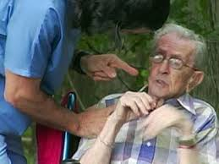  Objectives:  - Define elder abuse.  - Describe physical signs of abuse.  - Describe emotional signs of  abuse.  Warning signs of elderly abuse  (what to watch for)  Physical:  - Bruising, pressure marks, broken bones, burns  - Bruising around breasts or genital area can be from sexual abuse  - Bedsores, poor hygiene, unintended weight loss  Emotional:  - Changed behavior such as belittling, threats, and other uses of power  - Strained relationships with friends and family  - Frequent arguments between the caregiver and the elderly person
  Elderly Abuse
  What is it?
  Elderly abuse is a term referring to any knowing, intentional, or negligent act by a caregiver or any other person that causes harm or serious risk of harm to a vulnerable adult.
  This can be categorized into the following:
  Physical- force that results in bodily harm, pain, and/or impairment. This may include assault, battery, and inappropriate restraint.
  Sexual- A non-consensual act of sexual contact with an elderly person.
  Emotional- occurs when an elderly patient experiences trauma after being abused. Examples may be embarrassment or humiliation.
  Abandonment- when an elder in deserted by their caregiver or any other person who’s responsibility is to watch over the elder.
  Neglect- is failure of an elderly patients caregiver to provide the essentials for life
  ( (food, water, shelter)
  Contact Us
  Phone: [Telephone]
  Email: [Email address]
  Web: [Web address]
  (Food, water, shelter), healthcare, and protection.
  Exploitation- an action or fact of treating someone unfairly in order to benefit from their resources. Taking pills, money, or other assets.
  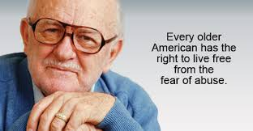
  Name Here
    - Date HERE
    - Nursing 302

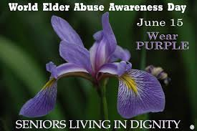
Why are the elderly easy targets for abuse?
- People over the age of 50 control 70% of
the worlds wealth
- Many seniors do not know the value of
their property and other assets
- Disabilities make them have to depend on
others for care and support
- Easy to predict due to predetermined
schedules and payment
- Technology advancements make it hard for
elderly patients to keep track of bills and
finances
- Many abusers believe that fragile, weak
victims will not be alive to pursue legal
actions against them
- Those with severe impairments are less
likely to take action against their abuser
because of illness or to avoid embarrassment
- The majority of seniors are unsophisticated
about financial matters
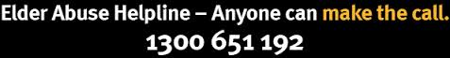
Where to find help?
Counseling: help overcome trauma, resolve
conflicts, asses options, plan for their safety. Any elderly person who feels as if they are being
Educate about resources, Co-dependency, abused can call this hotline for further assistance
And breaking through denial and shame. From trained professionals. They will understand
Legal Assistance: provided by private attorneys, your given situation and give you the best advice.
bar associations, and legal aid programs.
Used to recover assets or property, annulments
of bogus marriages, prosecution of offenders, and
obtain restitution.

References
Administration for Community Living. (n.d.). What is Elder Abuse? Retrieved from http://www.aoa.gov/AoA_programs/elder_rights/EA_prevention/whatisEA.aspx
National Committee for the Prevention of Elder Abuse. (2008). NCPEA. Retrieved from http://www.preventelderabuse.org/elderabuse/fin_abuse.html
National Center on Elder Abuse. (n.d.). Statistics/Data. Retrieved from http://www.ncea.aoa.gov/Library/Data/

National Committee for the Prevention of Elder Abuse. (2008). NCPEA. What services are available to stop abuse? Retrieved from http://www.preventelderabuse.org/elderabuse/help/help2.html
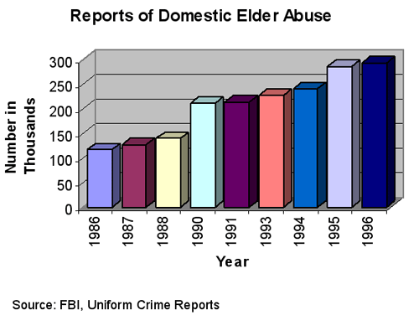  Trends in Elderly Abuse  - Statistically, elders with disabilities report being abused more often than those who do not have a mental or physical disability  - Research also shows that patients with dementia have a greater risk of being abused than elders without dementia  - The amount of reported elderly abuse cases has been increasing yearly, which is good and bad…  - Good because people are starting to recognize the warning signs and cues of elderly abuse  - Bad because the amount of elderly abuse cases are also increasing |  |  | Who are the culprits?  Family members  - Sons, daughters, grandchildren, and even spouses are to blame  - Also, friends conspire to abuse their elderly acquaintances  Caregivers  - Nursing home staff, physicians, and nurses  Strangers  - Many associated just for financial exploitation  - They earn the trust of the elderly person and wreak havoc on their financial records  Many of these perpetrators have alcohol and substance abuse problems and exploit the elderly for money or their medications.  “A nation’s greatness is measured by how it treats its weakest members.” -Gandhi |  |  | 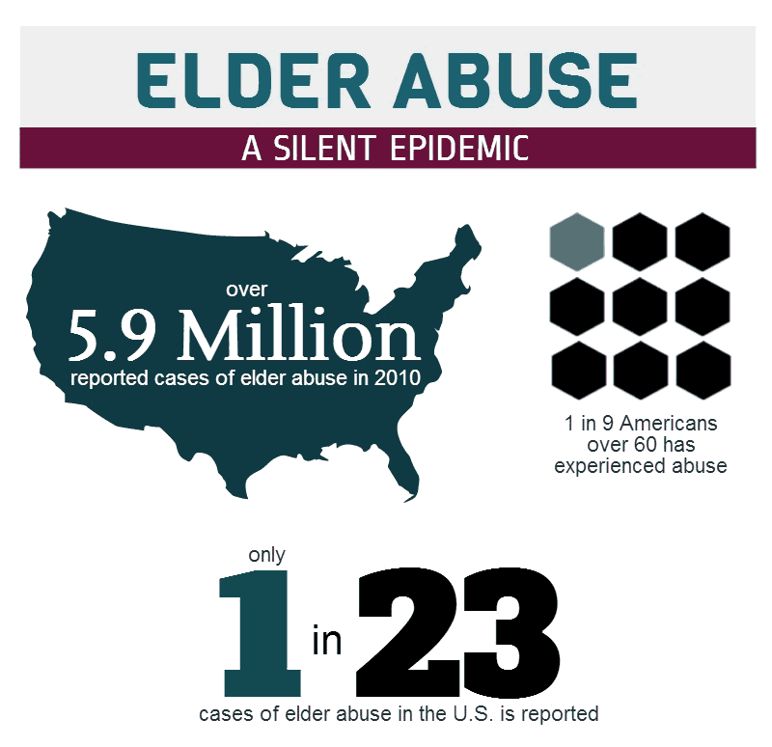  Who is at risk of elderly abuse?  The following characteristics increase an individual’s risk of abuse:  - Loneliness  - Isolation  - Being wealthy  - Suffering a recent loss  - Physical and/or mental disabilities  - Family members with alcohol or drug abuses problems  - Being unaware of finances

